1. Create an EBS and attach to two EC2 instance. Create an EBS and attach it to two EC2 instances.

Create an EFS and attach to two EC2 instance. Create an EBS and attach it to EC2 instance.

1. **EFS:**

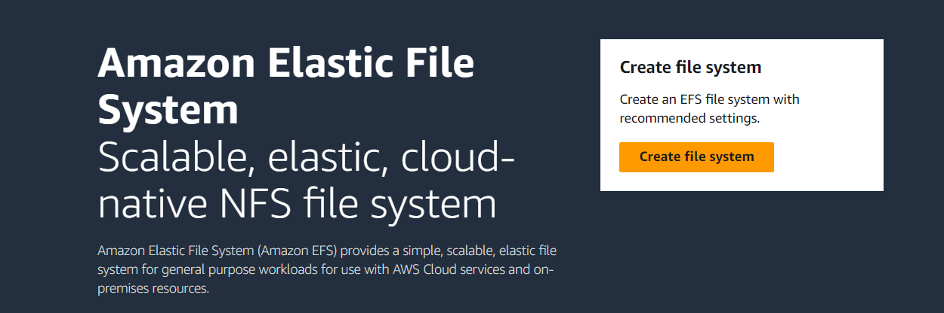

Step 1: Create security group

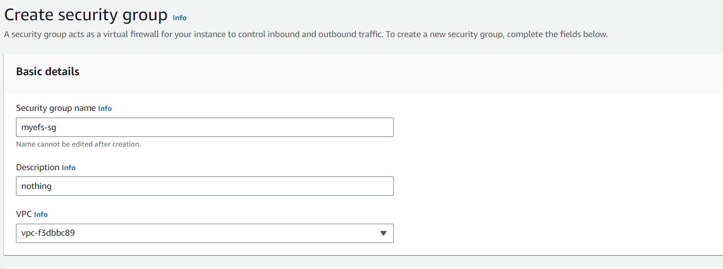

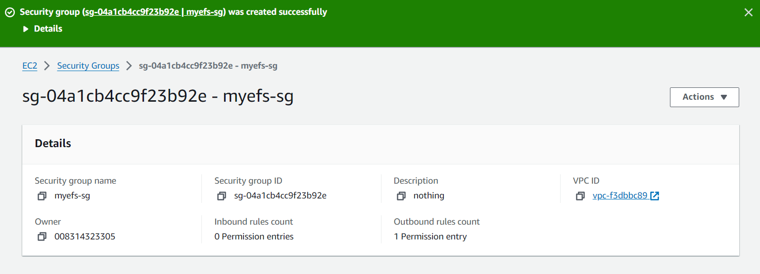

Step 2: Create EFS

Customize Security Group that we created

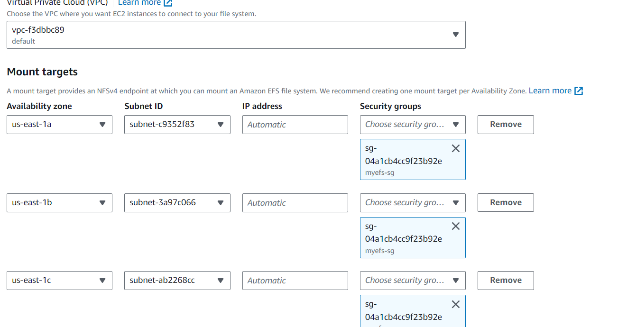

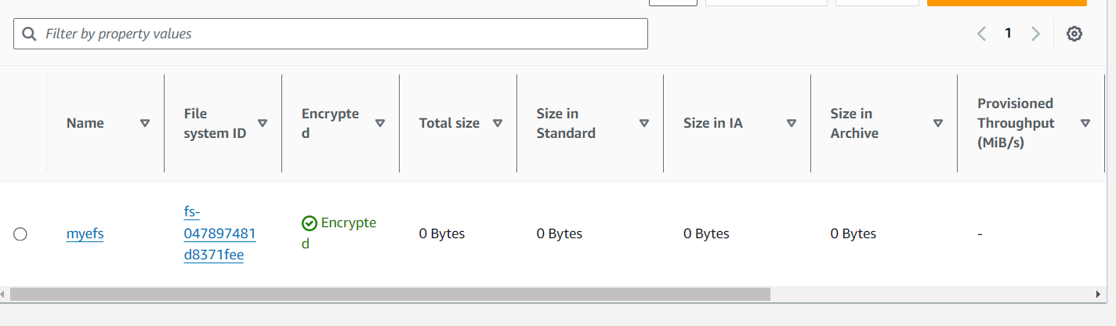

Step 3 : Launch Instance

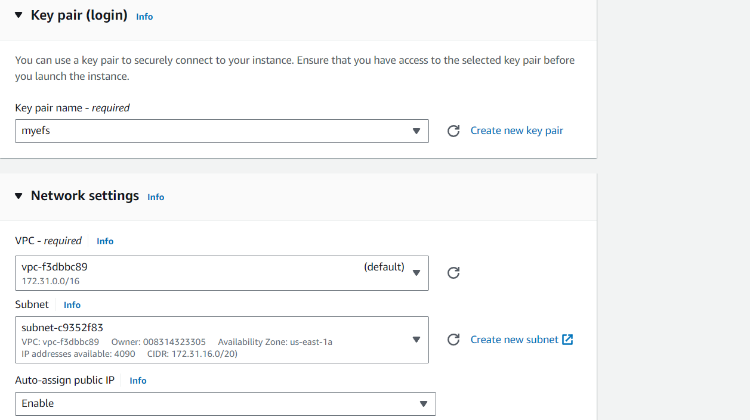

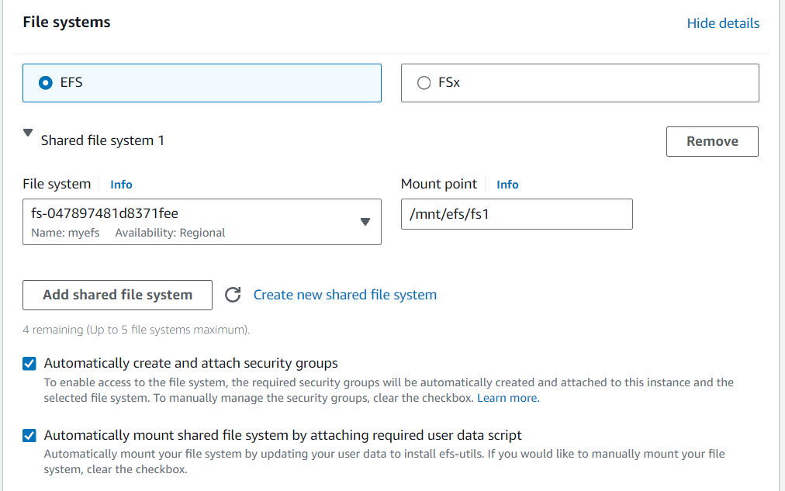

Step 4 : Connect

> sudo -i

>cd /mnt

>ls

>cd efs

>ls

>cd fs1

>vi file1

>touch f2 f3 f4

>mkdir m1 m2 m3

>ls

Step 5 : Create another instance

Connect

>Sudo -i

>cd /mnt

>ls

>cd efs

>ls

>cd fs1

>vi file2

>mkdir m4

>touch f5

>ls

After creating two instances and connecting we can check or we can display all the files that are created in both file systems i.e, we can check the files in EC1 that are created in EC2 and vice versa.

Hence, we can say that File Sharing can be done between two Instances that we have created.

1. **EBS:**

Elastic Block Storage

Create an Amazon EBS volume to attach to any EC2 instance in the same Availability Zone.

Step 1: Create and Launch Instance

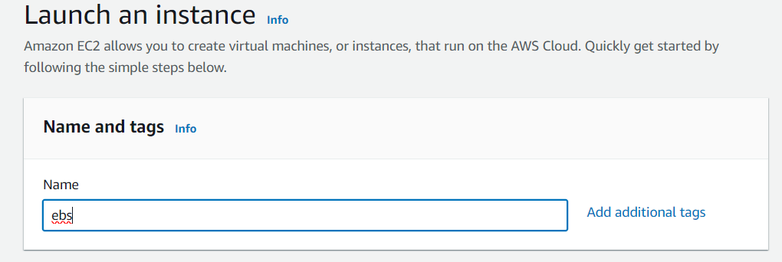

Step 2 : Create volume

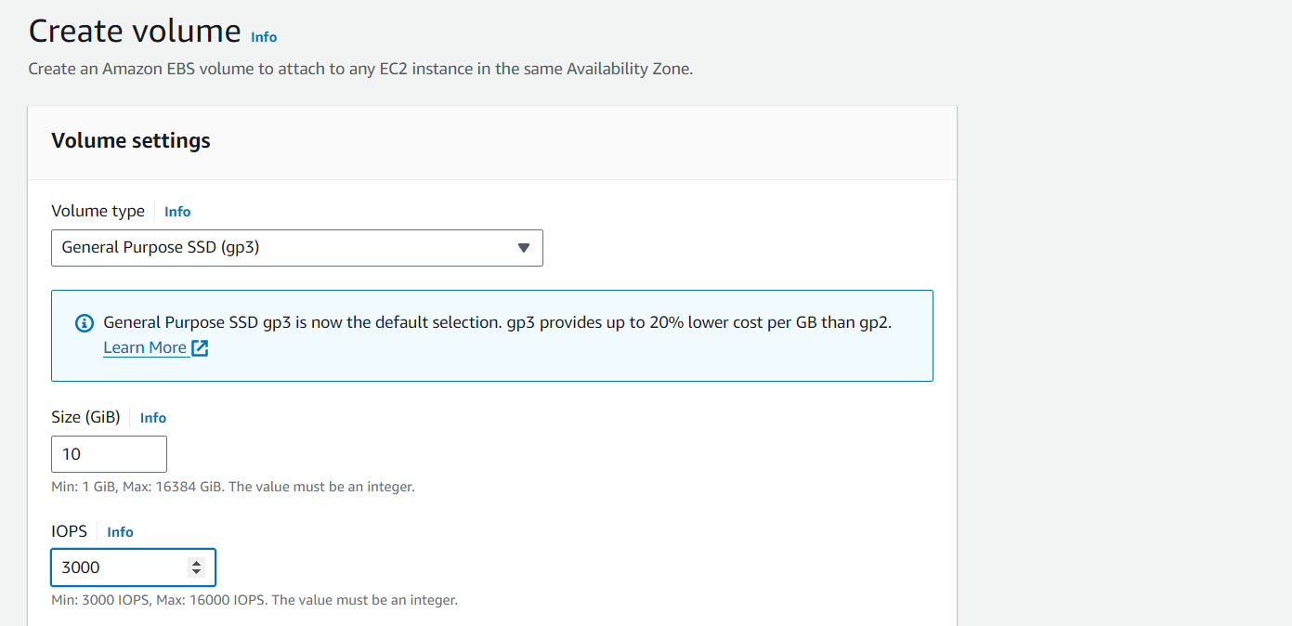

Create volume using specifications:

Size : 10

Io1

Iops : 3000

Create in the same server region and availability

Step 3 :

Click on action and then attach volume

Now attach instance

Device should be specified

Step 4: Connect

>df -h

>lsblk

>Connect Instance

>sudo -i

>mkfs -t xfs /dev/xvdf

>mkdir -p indu/vcube/122

>mount /dev/xvdf indu/vcube/122

>df -h

>cd indu/vcube/122

>vi file1

>ls

File1

Hence that file has been created in the storage we have been created.